**Are you an artist living in Central Bedfordshire?**

Tangled Feet are offering a year-long project to support, train and upskill 9 individual emerging artists or companies who are residents of Central Bedfordshire as part ofour **IGNITE** project.

**WHAT IS IGNITE?**

**This is a year-long mentoring and career development opportunity (participation is paid) for emerging artists in Central Beds, led by Tangled Feet Theatre Ensemble.** The project will bring together a community of local artists who can meet, learn, collaborate, and build a sustainable future for themselves, under the guidance of Tangled Feet’s core team. The project will offer 4 workshops across the year as well as mentoring and paid time to develop your own creative practice. The project is being funded by the UK Shared Prosperity Fund and Central Bedfordshire Council, and managed by the Bedfordshire and Luton Community Foundation.

**IS IT FOR ME?**

Do you live and have an artistic or participatory practice in Central Bedfordshire?

Do you need support with the business side of your practice?

Do you want to connect with other artists and build your creative network?

Do you need help building momentum, building future plans, gaining funding and maintaining your wellbeing?

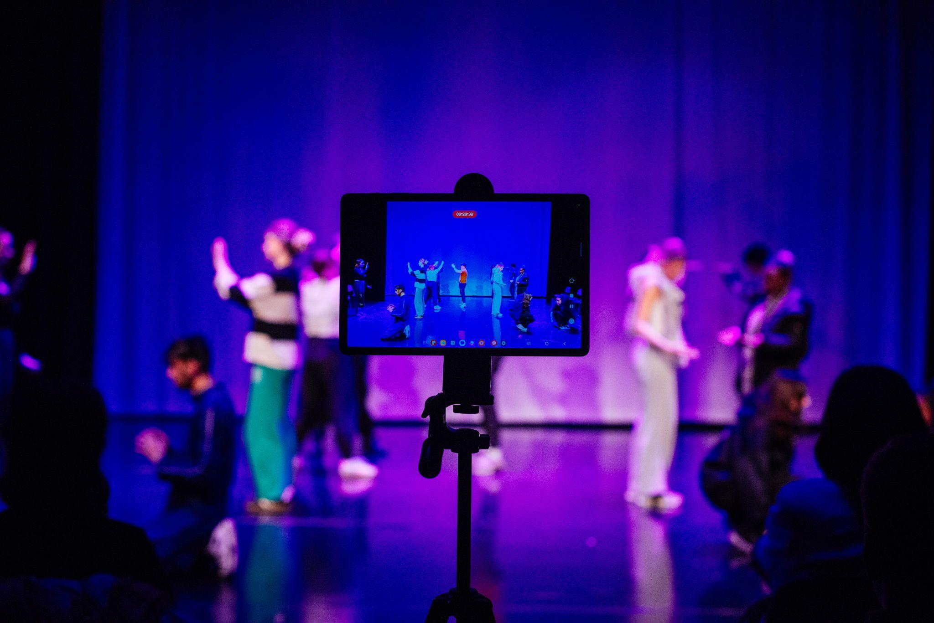

**Then, Ignite might be for you!**

**IGNITE** can offer you support with:

Artistic business planning

Strategy and making a plan

Building partnerships

Working with and for young people

Marketing and digital

Governance

Finance and fundraising

**IS IT PAID?**

**Yes, this is a paid opportunity.**

* Artists will receive a £150 fee for attending each workshop / mentor session
* 4 x workshops + 4 x days mentoring at £150 p/day = **£1200 TOTAL.**
* Creative development: Up to £750 towards the development of your future creative plans
* Travel will be covered if necessary.

**WHEN IS IT HAPPENING?**

The project kicks off in February 2025 with our workshops and mentoring sessions scheduled over 8 days throughout 2025.

**WHERE IS IT HAPPENING?**

We will be holding meet and greets in various locations in Central Bedfordshire where you can meet our Community Producer and learn more about **IGNITE** and how you can apply. For more info please contact [communityproducer@tangledfeet.com](mailto:communityproducer@tangledfeet.com) to arrange a meet up.

All workshops and mentoring sessions for the successful 9 participants will take place in various locations within Central Bedfordshire and online. These locations will be confirmed once we know and understand everyone's needs and accessibility requirements.

**ABOUT IGNITE:**

The project offers support from Tangled Feet, through mentoring and through four creative workshops led by different members of Tangled Feet's ensemble. Each workshop will focus on a different area of our team’s experience and expertise, including artistic business planning, building partnerships, working with and for young people, marketing and digital, governance, finance and fundraising, and creating/devising new work.

In addition to the programme of four workshops, each participant will be paired with a member of Tangled Feet's ensemble as a mentor.

We will also buddy you up with another member of the **IGNITE** cohort, giving you the opportunity to share your experience, offer support and to build creative and collaborative relationships.

All of this will be facilitated by Aimee Gomez, Tangled Feet’s Community Producer who has a broad knowledge and network of Central Bedfordshire arts. Aimee will manage your project

and be your first point of call and support in creating this new creative community in Central Bedfordshire.

**ABOUT TANGLED FEET:**

Tangled Feet is an artist-led ensemble based in Luton creating and touring work locally, nationally and internationally. We create original theatre through a collaborative working methodology that celebrates physicality and ensemble skills. TF is an artist-led ensemble - one of the few operating in the UK and has a broad and diverse group of artists and practitioners, many of whom have worked with us for many years.We create performances inside and outdoors: in theatres, on the streets, up the side of buildings and inside schools. We love sharing the creative process with new people and younger artists as an integral part of our production process, in workshops, residencies and participation projects. Through our partnerships locally we deliver educational programmes, performances and talent development and we are connected with the creative networks and partners in Luton. Alongside this, we have built an expansive delivery of therapeutic provision which supports young people with their mental health.

**APPLICATION PROCESS:**

Please send an expression of interest to: [communityproducer@tangledfeet.com](mailto:communityproducer@tangledfeet.com) by **Monday 3rd February**

**Please include**

- an explanation of your artistic practice

- a description sharing one or some of the main challenges you are encountering in your career

- why you'd like to come onboard the IGNITE programme and what you'd hope to gain

- any links or social media handles/website/CVs to your existing work

If you have any questions about the application process please contact [communityproducer@tangledfeet.com](mailto:communityproducer@tangledfeet.com)

We welcome written, audio or video applications.

Anticipated start date w/c 17th February 2025

Tangled Feet seeks to actively encourage applications from those with less representation in the arts. We specifically welcome applications from people with disabilities and those from Global Majority backgrounds.

All Tangled Feet policies can be viewed here <https://tangledfeet.com/about/our-policies>

